TSP Algorithm Performance Report
This report analyzes the performance of different combinations of constructive and perturbative methods for solving the Travelling Salesman Problem (TSP). The analysis is based on two metrics: Tour Cost and Time Taken.

Summary Table
Construction_Method | Perturbative_Method | Avg_Tour_Cost | Avg_Total_Time
Cheapest_Insertion | 2-opt | 28092.978952380952 | nan
Cheapest_Insertion | Node_Shift | 28331.545095238092 | nan
Cheapest_Insertion | Node_Swap | 29364.231952380953 | nan
Nearest_Neighbour | 2-opt | 28452.46547619048 | nan
Nearest_Neighbour | Node_Shift | 28855.506095238095 | nan
Nearest_Neighbour | Node_Swap | 29393.70204761905 | nan

Graphs
Figure 1: Average Tour Cost by Method Combination.
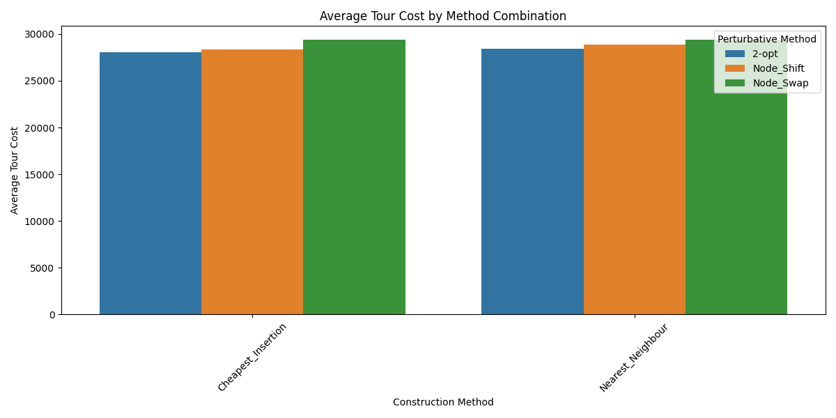
Figure 2: Average Time by Method Combination.
